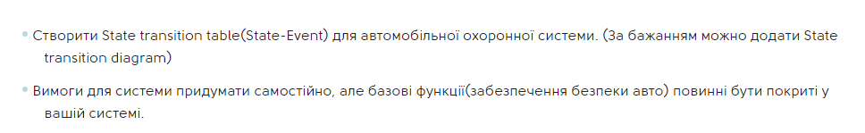

|  | Start button | Stop button | Reset button | Attempt to break into a car |
| --- | --- | --- | --- | --- |
| Switched off | doors locked, alarm system in standby mode |  |  | the car was stolen or robbed |
| Turned on |  | alarm system in standby mode | alarm system deactivated, doors unlocked | Alarm activated |
| Alarm activated |  | alarm deactivated, alarm system in standby mode | alarm system switched off |  |